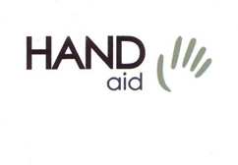
Order Form

Handaid AB E-mail: contact@handaid.se
Brostugevägen 18 Phone: +46 708 252129
SE-756 53 Uppsala Fax: +46 10 10 11 312
SWEDEN Eori No: SE5566887567

Date: |  | Order nr:
Buyer:
Delivery Address: |  | Invoice Address:
Phone: |  | Invoice Ref:
E-mail: |  | VAT No:

Send order
By e-mail  contact@handaid.se  By fax  +46 10 10 11 312 | By mail  Handaid AB  Brostugevägen 18  SE-756 53 Uppsala  SWEDEN

Comments:

 | Item |  | Amount |  |  |  |  | Price | Total
Thumb Support | 100 | Low, unlined | XXS | XS | S | M | L | 150:-
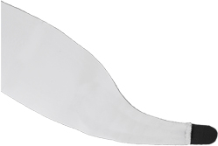  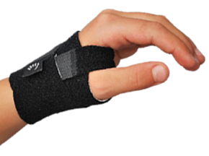 |  | Left, Beige
 |  | Right, Beige
 |  | Left, Blue
 |  | Right, Blue
 |  | Left, Camouflage
 |  | Right, Camouflage
 |  | Left, Black
 |  | Right, Black
 |  | Unlined, black laminated | XXS | XS | S | M | L | 200:-
 |  | Left, Laminated
 |  | Right, Laminated
 | Item |  | Amount |  |  |  |  | Price | Total
Thumb Support | 101 | Low, lined | XXS | XS | S | M | L | 150:-
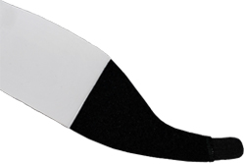 |  | Left, Beige
 |  | Right, Beige
 |  | Left, Blue
 |  | Right, Blue
 |  | Left, Camouflage
 |  | Right, Camouflage
 |  | Left, Black
 |  | Right, Black
 | Item |  | Amount |  |  |  |  | Price | Total
Thumb Support | 102 | Low, reinforced | XXS | XS | S | M | L | 150:-
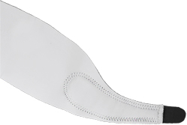 |  | Left, Beige
 |  | Right, Beige
 |  | Left, Blue
 |  | Right, Blue
 |  | Left, Camouflage
 |  | Right, Camouflage
 |  | Left, Black
 |  | Right, Black
 | Item |  | Amount |  |  |  |  | Price | Total
Thumb Support | 103 | Low, tripple reinforced | XXS | XS | S | M | L | 150:-
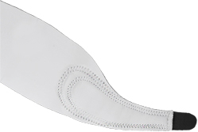 |  | Left, Beige
 |  | Right, Beige
 |  | Left, Blue
 |  | Right, Blue
 |  | Left, Camouflage
 |  | Right, Camouflage
 |  | Left, Black
 |  | Right, Black

 | Item |  | Amount |  |  |  |  | Price | Total
Thumb Support | 104 | Low, double layer | XXS | XS | S | M | L | 200:-
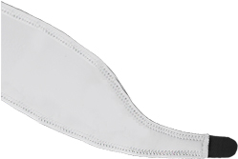 |  | Left, Beige
 |  | Right, Beige
 |  | Left, Blue
 |  | Right, Blue
 |  | Left, Camouflage
 |  | Right, Camouflage
 |  | Left, Black
 |  | Right, Black
 | Item |  | Amount |  |  |  |  | Price | Total
Thumb Support | 105 | Low, plastic reinforced | XXS | XS | S | M | L | 200:--
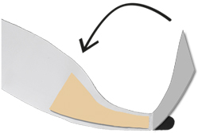 |  | Left, Beige
 |  | Right, Beige
 |  | Left, Blue
 |  | Right, Blue
 |  | Left, Camouflage
 |  | Right, Camouflage
 |  | Left, Black
 |  | Right, Black
Comments:

 | Item |  | Amount |  |  |  |  | Price | Total
Thumb Support | 200 | High | XXS | XS | S | M | L | 150:-
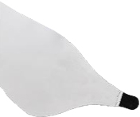  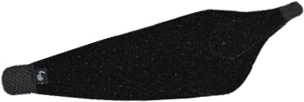  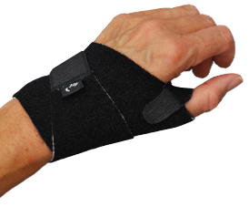 |  | Left, Beige
 |  | Right, Beige
 |  | Left, Blue
 |  | Right, Blue
 |  | Left, Camouflage
 |  | Right, Camouflage
 |  | Left, Black
 |  | Right, Black
 |  | Unlined, black laminated | XXS | XS | S | M | L | 200:-
 |  | Left, Laminated
 |  | Right, Laminated
 | Item |  | Amount |  |  |  |  | Price | Total
Thumb Support | 201 | High, lined | XXS | XS | S | M | L | 150:-
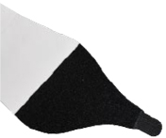 |  | Left, Beige
 |  | Right, Beige
 |  | Left, Blue
 |  | Right, Blue
 |  | Left, Camouflage
 |  | Right, Camouflage
 |  | Left, Black
 |  | Right, Black
 | Item |  | Amount |  |  |  |  | Price | Total
Thumb Support | 202 | High, reinforced | XXS | XS | S | M | L | 150:-
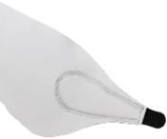 |  | Left, Beige
 |  | Right, Beige
 |  | Left, Blue
 |  | Right, Blue
 |  | Left, Camouflage
 |  | Right, Camouflage
 |  | Left, Black
 |  | Right, Black
 | Item |  | Amount |  |  |  |  | Price | Total
Thumb Support | 203 | High, tripple reinforced | XXS | XS | S | M | L | 150:-
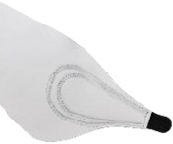 |  | Left, Beige
 |  | Right, Beige
 |  | Left, Blue
 |  | Right, Blue
 |  | Left, Camouflage
 |  | Right, Camouflage
 |  | Left, Black
 |  | Right, Black
 | Item |  | Amount |  |  |  |  | Price | Total
Thumb Support | 204 | High, double layer | XXS | XS | S | M | L | 200:-
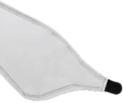 |  | Left, Beige
 |  | Right, Beige
 |  | Left, Blue
 |  | Right, Blue
 |  | Left, Camouflage
 |  | Right, Camouflage
 |  | Left, Black
 |  | Right, Black
 | Item |  | Amount |  |  |  |  | Price | Total
Thumb Support | 205 | High, plastic reinforced förstärkt | XXS | XS | S | M | L | 200:-
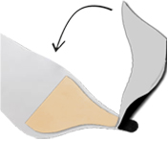 |  | Left, Beige
 |  | Right, Beige
 |  | Left, Blue
 |  | Right, Blue
 |  | Left, Camouflage
 |  | Right, Camouflage
 |  | Left, Black
 |  | Right, Black
Comments:

 | Item |  | Amount |  | Price | Total
Wrist Support | 300 | With thumb hole | Small | Large | 200:-
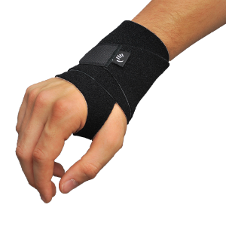 |  | Left, Beige
 |  | Right, Beige
 |  | Left, Blue
 |  | Right, Blue
 |  | Left, Camouflage
 |  | Right, Camouflage
 |  | Left, Black
 |  | Right, Black
 |  | Black, laminated | Small | Large | 250:-
 |  | Left, Laminated
 |  | Right, Laminated
 | Item |  | Amount |  | Price | Total
Wrist Support | 301 | Without thumb hole | Small | Large | 200:-
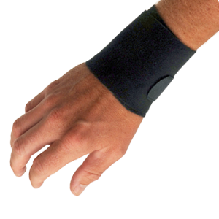 |  | Left, Beige
 |  | Right, Beige
 |  | Left, Blue
 |  | Right, Blue
 |  | Left, Camouflage
 |  | Right, Camouflage
 |  | Left, Black
 |  | Right, Black
 |  | Black, laminated | Small | Large | 250:-
 |  | Left, Laminated
 |  | Right, Laminated
 | Item |  | Amount |  | Price | Total
LE/ME Wrap | 400 |  | Small | Large | 200:-
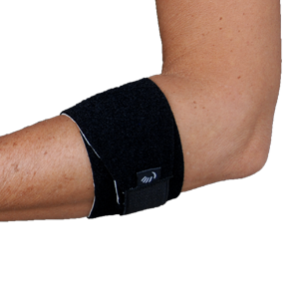 |  | Beige
 |  | Blue
 |  | Camouflage
 |  | Black
 |  | Black, laminated | Small | Large | 250:-
Comments:

 | Item |  | Amount |  |  |  |  | Price | Total
Supination Wrap | 500 | Unlined | XXS | XS | S | M | L | 300:-
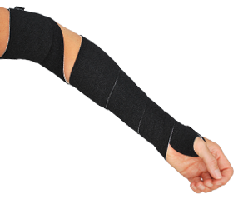 |  | Left, Beige
 |  | Right, Beige
 |  | Left, Blue
 |  | Right, Blue
 |  | Left, Camouflage
 |  | Right, Camouflage
 |  | Left, Black
 |  | Right, Black
 |  | Unlined, black laminated | XXS | XS | S | M | L | 350:-
 |  | Left, Laminated
 |  | Right, Laminated
 | Item |  | Amount |  |  |  |  | Price | Total
Supination Wrap | 501 | Lined | XXS | XS | S | M | L | 300:-
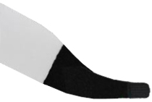 |  | Left, Beige
 |  | Right, Beige
 |  | Left, Blue
 |  | Right, Blue
 |  | Left, Camouflage
 |  | Right, Camouflage
 |  | Left, Black
 |  | Right, Black
 | Item |  | Amount |  |  |  |  | Price | Total
Supination Wrap | 502 | Reinforced | XXS | XS | S | M | L | 300:-
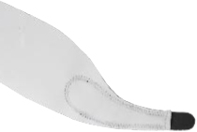 |  | Left, Beige
 |  | Right, Beige
 |  | Left, Blue
 |  | Right, Blue
 |  | Left, Camouflage
 |  | Right, Camouflage
 |  | Left, Black
 |  | Right, Black
 | Item |  | Amount |  |  |  |  | Price | Total
Supination Wrap | 503 | Tripple reinforced | XXS | XS | S | M | L | 300:-
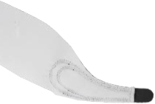 |  | Left, Beige
 |  | Right, Beige
 |  | Left, Blue
 |  | Right, Blue
 |  | Left, camouflage
 |  | Right, camouflage
 |  | Left, Black
 |  | Right, Black
Comments:

 | Item |  | Amount |  |  |  |  |  | Price | Total
Gripsizer | 600 |  | Green bag |  |  | Blue bag |  |  | 950:-
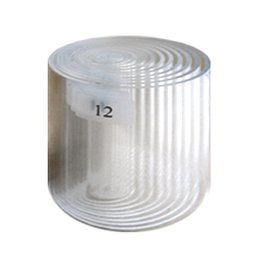 |  | Set of Plexiglas cylinders  ø 1-12 cm.  Delivered with storage bag.
 | Item |  |  |  |  |  |  |  | Price | Total
FlexFixer | 601 |  | Amount |  |  |  |  |  | 75:-
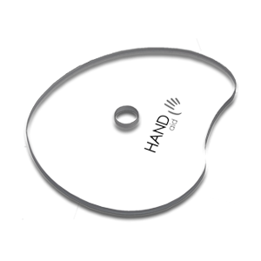 |  | Hand Therapy disc.
 | Item |  | Amount |  |  |  |  |  | Price | Total
Fabrifoam Material | 700 |  | Black |  | Blue |  | Sand |  | 550:-
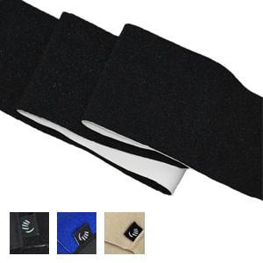 |  | Fabrifoam Fabric sold by the meter widh 60 cm.
 | Item |  |  |  |  |  |  |  | Price | Total
Outrigger | 800/801 |  | Amount |  |  |  |  |  | 90:-
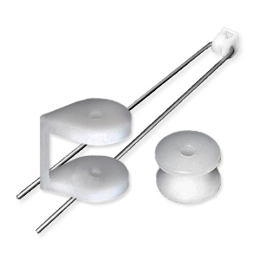 |  | Outrigger on metal thread.
 |  | Outrigger, no metal thread.
 | Item |  | Amount |  |  |  |  |  | Price | Total
CI- glove | 900 |  | XS | S |  | M |  | L | 400:-
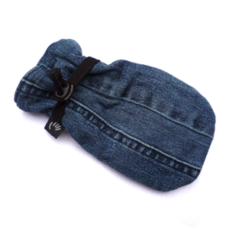 |  | CI-glove for CI-therapy, child.  Contact us for today’s choice  of fabric, color and pattern.
 |  |  | S |  | M |  | L |  | 400:-
CI-glove for CI-therapy, adult.
Contact us for today’s choice
of fabric, color and pattern.
Prices in SEK. Postage fees will be added. |  |  | Total

Send order
By e-mail  contact@handaid.se  By fax  +46 10 10 11 312 | By mail  Handaid AB  Brostugevägen 18  SE-756 53 Uppsala  SWEDEN

